June 13, 2012

To: Alexander Densmore
Editor
Journal of Geophysical Research – Earth Surface

From: Gregory S. Okin
Professor

okin@ucla.edu
UNIVERSITY OF CALIFORNIA, LOS ANGELES UCLA

BERKELEY  DAVIS  IRVINE  LOS ANGELES  RIVERSIDE  SAN DIEGO  SAN FRANCISCO SANTA BARBARA  SANTA CRUZ

DEPARTMENT OF GEOGRAPHY
1255 BUNCHE HALL
405 HILGARD AVENUE
LOS ANGELES, CALIFORNIA 90095-1524
(310) 825-1071 FAX (310) 206-5976

Re: 2012JF002375

Dear Dr. Densmore,
Thank you for continuing to consider manuscript #2012JF002375, which we have newly entitled “Evaluation of a new model of aeolian transport in the presence of vegetation.” In addition, we thank you for the additional time to make our revisions.
Our revisions are quite substantial. In response to the request by you, the Associate Editor, and the reviewers, we have added comparisons of the Okin [2008] model with other models in the literature. This has dramatically lengthened the paper. We believe that this new component has also substantially strengthened the manuscript. Of course, we have also addressed, to the best of our ability, the additional AE and reviewers’ comments.
In your decision letter, you asked that we explain why this manuscript went beyond merely a validation exercise of a single model. The new comparison with existing models partly addresses this. However, our main response to this point, which now appears throughout the manuscript, is that the way in which the Okin [2008] model handles shear stress portioning on the surface is fundamentally different from existing models. It is, we believe, both a more realistic representation of the surface as well as a view that is supported by existing field data and the new analyses in this manuscript. In this way, we believe that the manuscript adds significantly to our understanding of the physics of aeolian transport by upending the existing view and treatment of shear stress partitioning as it relates to aeolian transport.

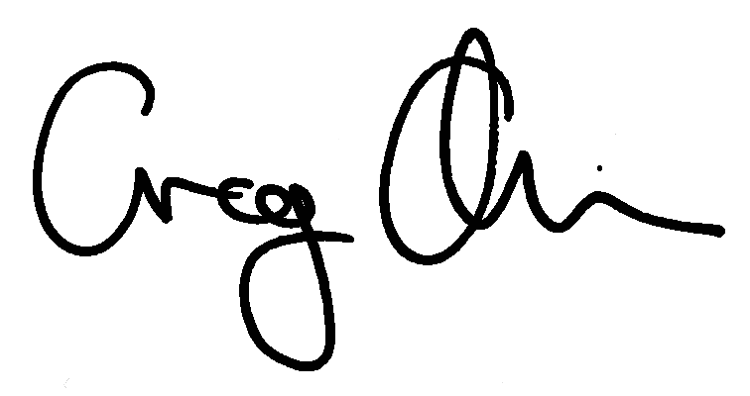
Thank you again,

Gregory S. Okin

